BBC QUIZ



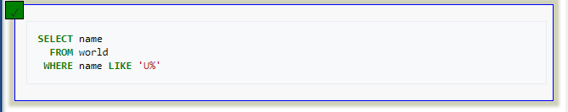

2. Select the code which shows just the population of United Kingdom?

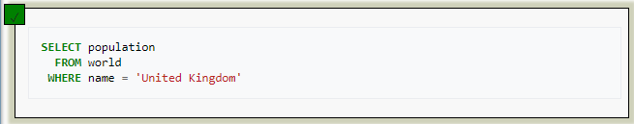

3. Select the answer which shows the problem with this SQL code - the intended result should be the continent of France:





